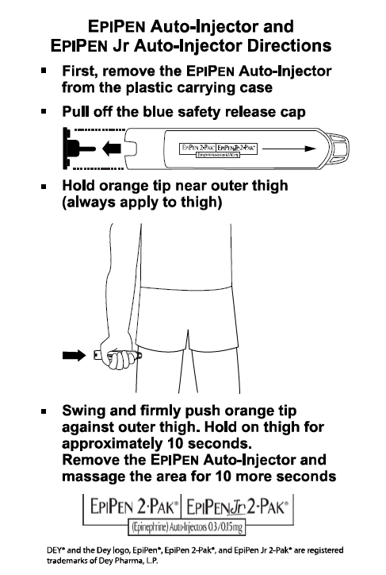 | 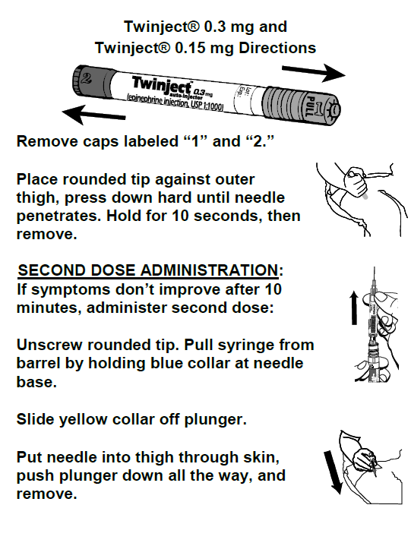
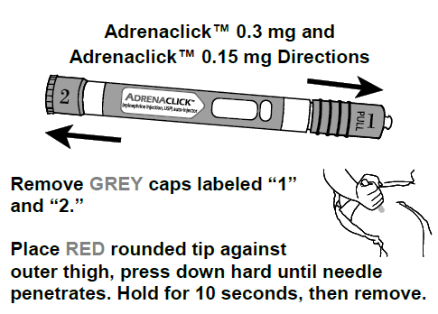 | Staff Trained to use Epi Pen  Name & Date  - _______________________________________  - _______________________________________  - _______________________________________  - _______________________________________  - _______________________________________  - _______________________________________  - _______________________________________

Monitoring
Stay with student; alert healthcare professionals and parent. Tell rescue squad Epi was given; request ambulance with epinephrine. Note time epinephrine was administered. A second dose of epinephrine can be given 5 minutes or more after the first if symptoms persist or recur. For severe reaction, consider keeping student lying on back with legs raised. Treat student even if parents cannot be reached.

Student Name ________________________________________
School______________________________________ Teacher or ID# ______________________________
School Nurse ___________________________ Phone_______________________ Fax____________________
Contacts:
Call 911 / Doctor:______________________________________________ Phone: (___)_____-_________ Parent/Guardian:_______________________________________________ Phone: (___)_____-_________
Other Emergency Contact: _______________________________________ Phone: (___)_____-_________

Notes:

